**Magento Checkbook Extension (Instllation Guide)**

Attached zip (cedcoss_checkbook.zip) contains two folders named app & js. Simply Extract these two folders within magento root directory (Your root directory on server contains the folder app, design, var etc. Just paste those app and js folder within this root dir. After that app folder in extension zip merge with root app folder and js folder will merge with root js folder). After extracting files, log in to your admin panel and go to **System-> Configuration-> Payment Method**

By clicking the tab ‘Checkbook Payment’ you can configure the ‘Checkbook API Extension’ (refer the screenshot given below.)

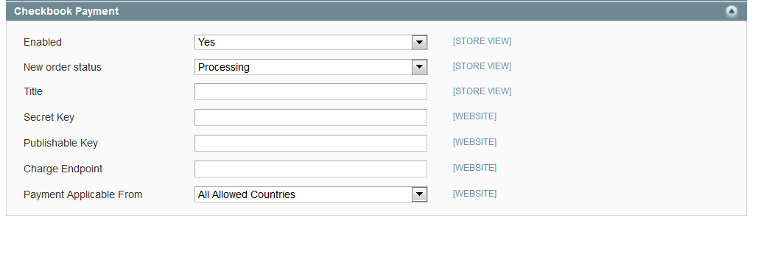

If you could not find that tab or any 404 error or Access Denied message (during first time installation) then please try following steps:

1. Log out the admin session and then login and ceck it once again.
2. Go to ‘Admin->System-Cache Management’ and click on ‘Flush Magento Cache’ and check it again.

Below are the fields which must be filled from backend.

**Enabled** -> ‘Yes’ (Don’t forget to enable this option.)

**New Order Status** -> You can set the new order status from here. (What I set is ‘processing’). Means when user creates order with thins payment option order will get this status.

**Title** -> Set the title from here (It will show under payment information on checkout page.)

(What I set here is ‘Pay By Checkbook’)

**Secret Key** -> Put your ‘secret key’ here which you got from ‘checkbook.io’

(I set here: C4WCmvYHCKFmMV0jHYQC792XEaSE9L6rfUWfyI3vP1o)

**Publishable Key** -> Put your ‘publishable key’ here which you got from ‘checkbook.io’

(I set here: MJ95Gjr9G6wBKwBiPbYG9JavvGnG4lnyC6QSZt9G8Ag)

**Charge Endpoint** -> This is the API charge point URL.(At last here: <https://www.checkbook.io/api/charge>)

Now after saving these setting you can find a new payment option on frontend checkout page:

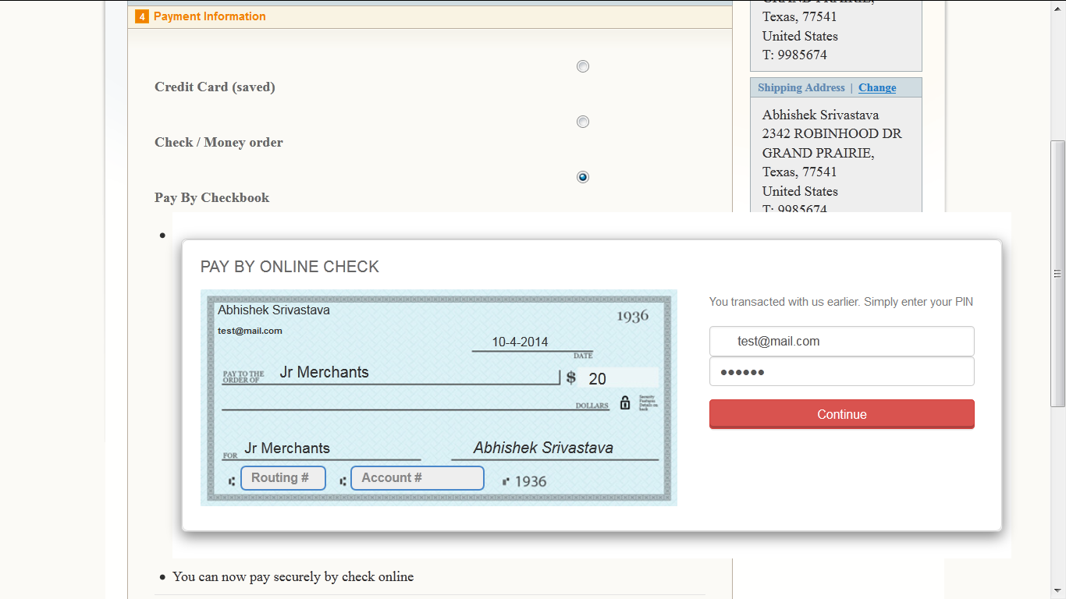

After submit your order from backend you can get ‘Success Message’ otherwise in case of error ‘An error message’ will be there.

Success Message:

